

**Jewelry Management System**

**Software Requirement Specification**

– Ho Chi Minh, 10/10/2024–

SIGNATURE PAGE

**ORIGINATOR:** Group 13 10/10/2024

Producer

* Nguyễn Khánh Huy - 22520560
* Trần Đình Phương Linh - 22520778
* Đặng Thị Ngọc Minh - 22520857
* Nguyễn Thị Thúy Hằng - 21520822

**REVIEWERS:** Team 14 29/10/2024

Customer

**APPROVAL:** Nguyễn Thị Thanh Trúc XX/XX/2024

Instructor

Table of Contents

I. Record of Changes 5

II. Software Requirement Specification 6

1 INTRODUCTION 6

1.1 Purpose 6

1.2 Document conventions 6

1.3 Project scope and product features 6

1.4 References 6

2 OVERALL DESCRIPTION 7

2.1 Product Perspective 7

2.2 User Classes and Characteristics 7

2.3 Operating Environment 7

2.4 Design and Implementation Constraints 7

2.5 Assumptions and Dependencies 8

3 Functional Requirements 9

3.1 User Requirements 9

3.2 Diagram 10

3.3 Log In: 15

3.4 Sign Up: 17

3.5 Product Management 18

3.6 Product Type Management: 23

3.7 Provider Management: 29

3.8 Purchase Order Management: 34

3.9 Sell Order Management: 43

4 Non-Functional Requirements 50

4.1 External Interfaces 50

4.2 Quality Attributes 50

5 Data Requirements 53

5.1 Logical Data Model 53

5.2 Data Dictionary 53

5.3 Reports 56

6 Requirement Appendix 57

6.1 Business Rules 57

6.4 Common Requirements 57

6.7 Application Messages List 57

# Record of Changes

|  |  |  |  |
| --- | --- | --- | --- |
| Date | A* M, D | In charge | Change Description |
| 13/10/2024 | A | Initial | Add requirement list |
| 17/10/2024 | A | Add Scope and Vision | Define Scope and Vision |
| 20/10/2024 | A | Add Functional Requirement | Add use case, model diagram, business rules |
| 23/10/2024 | A | Add Non-Functional Requirement | Add Non-Functional Document |
| 23/10/2024 | M | Update use case | Update use case follow JMS |
| 23/10/2024 | M | Update Non-Functional Requirement | Update Non-Functional Requirement follow use case |

*A - Added M - Modified D - Deleted

# Software Requirement Specification

## INTRODUCTION

### Purpose

This SRS describes the functional and nonfunctional requirements for software release of the Jewelry Management System (JMS). This document is intended to be used by the members of the project team who will implement and verify the correct functioning of the system. Document Conventions

### Document conventions

No special typographical conventions are used in this SRS.

### Project scope and product features

#### Product features

The aim of this project is to develop a software system designed to streamline the management of a jewelry business. The Jewelry Management System (JMS) provides essential tools for managing various aspects of the business, ensuring efficient operations and improved customer service. The system encompasses the following key functionalities:

* Login/Register
* Homepage
* Manage Products
* Manage Product Types
* Manage Supplier
* Manage Purchase Order
* Manage Sales Order

#### Project scope

Applying knowledge acquired from the Software Engineering Fundamentals course and previous studies to develop the management software.

Ensuring the software meets all specified core functions while allowing for the potential development of additional features. The software will be designed to be user-friendly, fulfilling the operational requirements of the jewelry store.

### References

* SES Business rules: Defines or constrains some aspect of business in SES
* SES Software Detail Design: Deals with the implementation part of what is seen as a system and its sub-systems
* SES Use Case: A description of how a person who actually uses that process or system will accomplish a goal

## OVERALL DESCRIPTION

### Product Perspective

The Jewelry Management System is a new software solution that streamlines the current processes in jewelry retail operations. The context diagram in Figure 1 illustrates the external entities and system interfaces for release 1.0. This system is designed to evolve through multiple releases, with future enhancements aimed at integrating online ordering services for local customers and enabling user login and database updates.

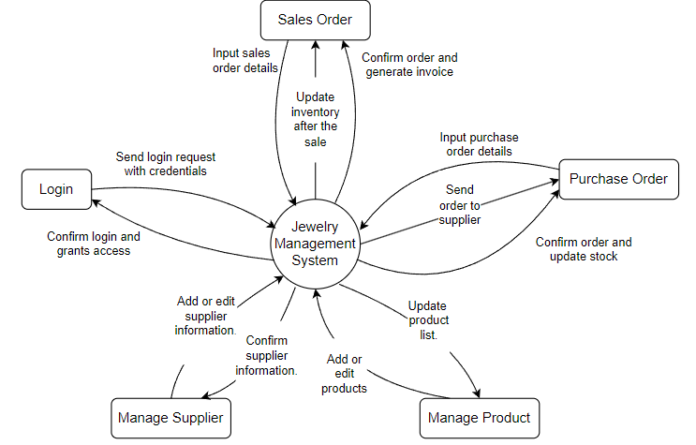

Figure 2.1‑1: Context diagram for release 1.0 of the Jewelry Management System.

### User Classes and Characteristics

|  |  |
| --- | --- |
| Admin | Admin can access all function in JMS |

### Operating Environment

|  |  |
| --- | --- |
| OE-1: | The JMS shall operate on a server running the current corporate-approved versions of Windows. |
| OE-2: | The SES shall permit user access from the corporate Intranet, from a VPN Internet connection. |

### Design and Implementation Constraints

|  |  |
| --- | --- |
| CO-1: | The system’s design, and maintenance documentation shall conform to the JMS Detailed Design |
| CO-2: | The system shall use the current corporate standard Oracle database engine |

### Assumptions and Dependencies

|  |  |
| --- | --- |
| AS-1: | The management of products, services, and transactions in the jewelry store is open to all transactions such as sales, purchases, and service requests, following specific established procedures. |
| DE-1: | The operation of the store management system depends on changes in the number of products and services available to offer customers. |
| DE-2: | The operation of the store management system relies on changes in the constraints of transaction processes, impacting the results of revenue and profit. |

## Functional Requirements

### User Requirements

#### The actors

|  |  |  |
| --- | --- | --- |
| # | Main functions | Admin |
| 1 | Login for Admin | x |
| 2 | Register | x |
| 3 | Home page | x |
| 4 | Manage Products | x |
| 5 | Manage Product Types | x |
| 6 | Supplier Management | x |
| 7 | Manage Purchase List | x |
| 8 | Manage Sales List | x |

### Diagram

#### Use Cases Diagram

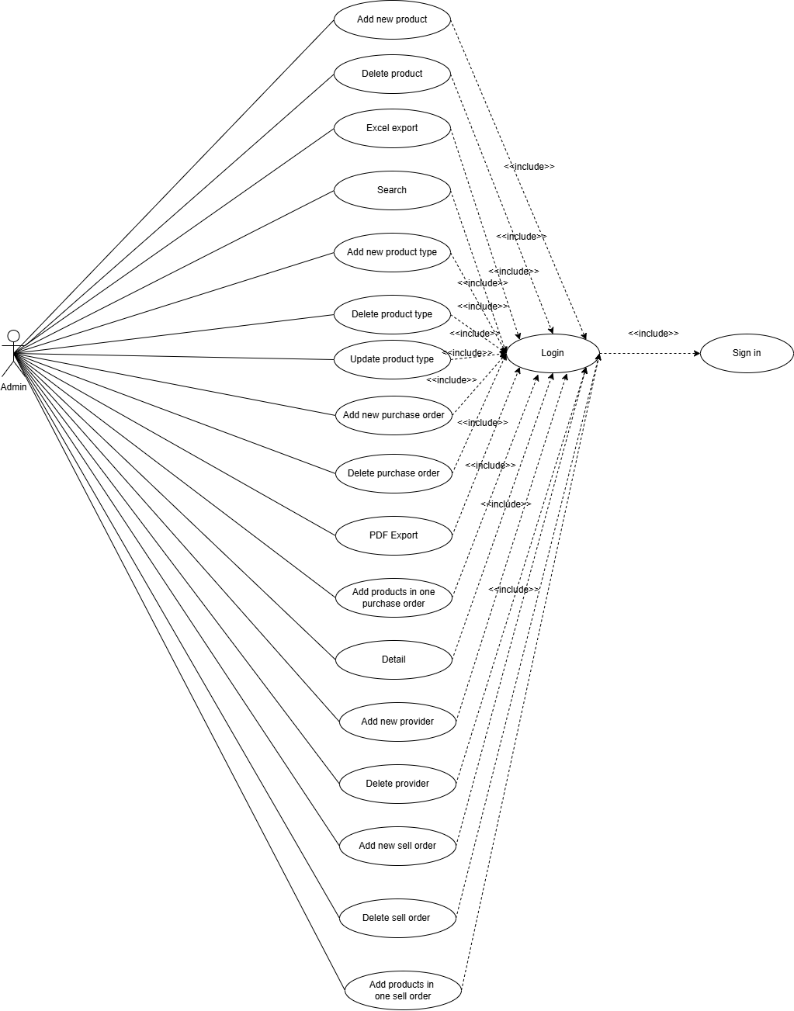

Figure 3.2‑1: Use Cases Diagram

#### Descriptions

|  |  |  |  |
| --- | --- | --- | --- |
| **ID** | **Use Case** | **Actors** | **Use Case Description** |
| 01 | Add new product | Admin | The user enters their information into input fields. |
| 02 | Delete product | Admin | The JMS system deletes the selected product. |
| 03 | Excel export | Admin | The system provides the function of exporting an Excel table of product lists on the system |
| 04 | Search | Admin | Look up code |
| 05 | Add new product type | Admin | The user enters their information into input fields |
| 06 | Delete product type | Admin | The JMS system deletes the selected product type. |
| 07 | Update product type | Admin | The JMS system updates the selected product type. |
| 08 | Add new purchase order | Admin | The user enters their information into input fields |
| 09 | Delete purchase order | Admin | The JMS system deletes the selected purchase order. |
| 10 | PDF export | Admin | The user selects a purchase order, then the system provides the function of exporting a PDF file of purchase order on the system |
| 11 | Add products in one purchase order | Admin | The user selects the offer and presses the add product button |
| 12 | Detail | Admin | The user selects a purchase order, then the system provides the function of viewing purchase order on the system |
| 13 | Log in | Admin | Login to the system |
| 14 | Sign up | Admin | Sign up a new account |
| 15 | Add provider | Admin | Add new provider to the system |
| 16 | Delete provider | Admin | Delete provider from the system |
| 17 | Add new sell order | Admin | Add new sell order to the system |
| 18 | Delete sell order | Admin | Delete sell provider from the system |
| 19 | Add product in one order | Admin | Add product to the system |

#### Screens Flow

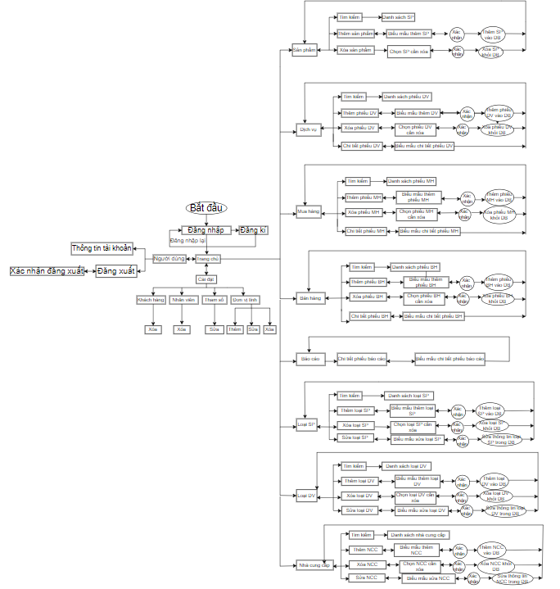

Figure 3.2‑2: Data Flow Diagram

#### Screen Descriptions

*[Provide the descriptions for the screens in the Screens Flow above]*

|  |  |  |  |
| --- | --- | --- | --- |
| **#** | **Feature** | **Screen** | **Description** |
| 1 | Log In | Log In | Login to the system |
| 2 | Sign Up | Sign Up | Sign up to log in |
| 3 | Add new product | Add Product | Add new product into system |
| 4 | Delete product | Product Management | Delete a product |
| 7 | Add new product type | Add product type | Add new product type |
| 8 | Delete product type | Product type | Delete a product type |
| 9 | Update product type | Product Type | Update a product type |
| 10 | Add new purchase order | Add purchase order | Add new purchase order |
| 11 | Delete purchase order | Purchase order | Delete a purchase order |
| 12 | Add products in one order | Add order detail | Add new roduct in the order |
| 13 | Detail | Detail information | View detail information |
| 14 | Add provider | Add provider | Add provider to the system |
| 15 | Delete provider | Provider Management | Delete a provider |
| 16 | Add new sell order | Add sell order | Add new sell product to the system |
| 17 | Delete sell order | Sell order management | Delete sell order from the system |
| 18 | Add product sell order | Add product to sell order | Add new product to sell order |

#### Screen Authorization

*[Provide the system roles authorization to the system features (down to screens, and event to the screen activities if applicable) in the table form as below – replace Role1, Role2,… with your specific system user role names]*

|  |  |
| --- | --- |
| **Screen** | **Admin** |
| <<Login>> | X |
| <<Sign Up>> | X |
| <<Product Management>> | X |
| Add New Product | X |
| Delete Product | X |
| Search Product | X |
| Excel Export | X |
| <<Purchase Order>> | X |
| Add New Purchase Order | X |
| Delete New Purchase Order | X |
| View Detail Purchase Order | X |
| Search Purchase Order | X |
| Excel Export | X |
| PDF Export | X |
| <<Product Type Management>> | X |
| Add New Product Type | X |
| Delete Product Type | X |
| Update Product Type | X |
| Search Product Type | X |
| Excel Export | X |
| <<Provider Management>> | X |
| Add New Provider | X |
| Search | X |
| Delete Provider | X |
| Excel Export | X |
| <<Sale Order Management>> | X |
| Add Sale Order | X |
| Delete Sale Order | X |
| Search | X |
| Excel Export | X |

#### Non-Screen Functions

*[Provide the descriptions for the non-screen system functions, i.e batch/cron job, service, API, etc.]*

|  |  |  |  |
| --- | --- | --- | --- |
| **#** | **Feature** | **System Function** | **Description** |
| 1 | Unit | Calculation Unit | Used to quantify products |
| 2 | Preparement rate | Calculation Unit | Used to specify the minimum amount to be paid before using the service |
| 3 | Employee Management | Manage employee and manager information | Manage employee and manager information, including id, name, phone number, date of birth and can export to excel |
| 4 | Customer Management | Manage customer in the system | Manage customer information, including id, name, phone number and can export to excel |

#### Entity Relationship Diagram

*[Provide the entity relationship diagram and the entity descriptions in the table format as below]*

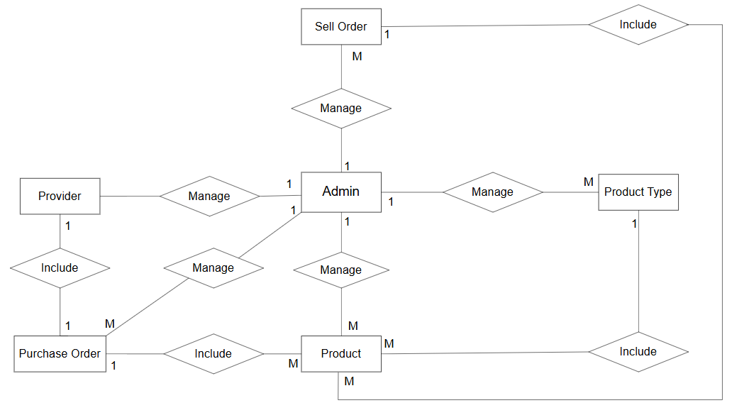

**Entities Description**

|  |  |  |
| --- | --- | --- |
| **#** | **Entity** | **Description** |
| 1 | Admin | Admin manages the remaining entities |
| 2 | Provider | Provider is included in the purchase order |
| 3 | Product | Product is included in product type and sell order |
| 4 | Product Type | Managed only by admin |
| 5 | Purchase Order | Managed only by admin and it itself manages providers and products |
| 6 | Sell Order | Managed only by admin and it itself manages products |

### Log In:

#### Log In:

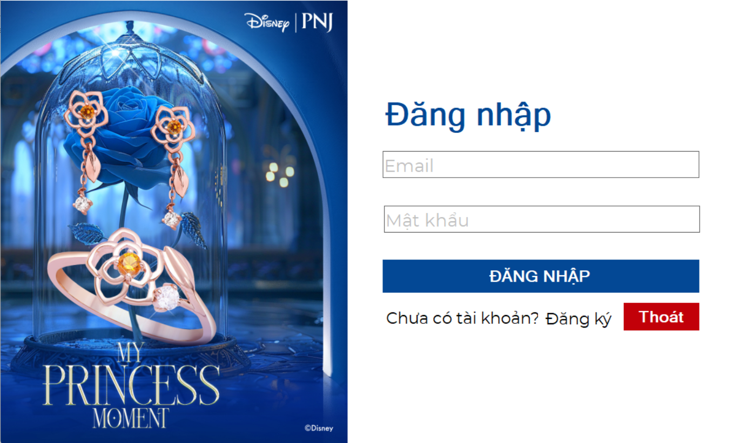

This screen is the first screen that appears when running the program. This screen includes login, registration and exit buttons.

* Function trigger: none because this is the first screen that appears, display time is 1.5 seconds.
* Function description: actor is admin, the purpose is to log in to the system, the interface includes email, password, login button, account creation button and exit button. When clicking on the login button, the email and password will be displayed. Check the database to see if the account exists
* Screen layout:
* Login:



* Exit

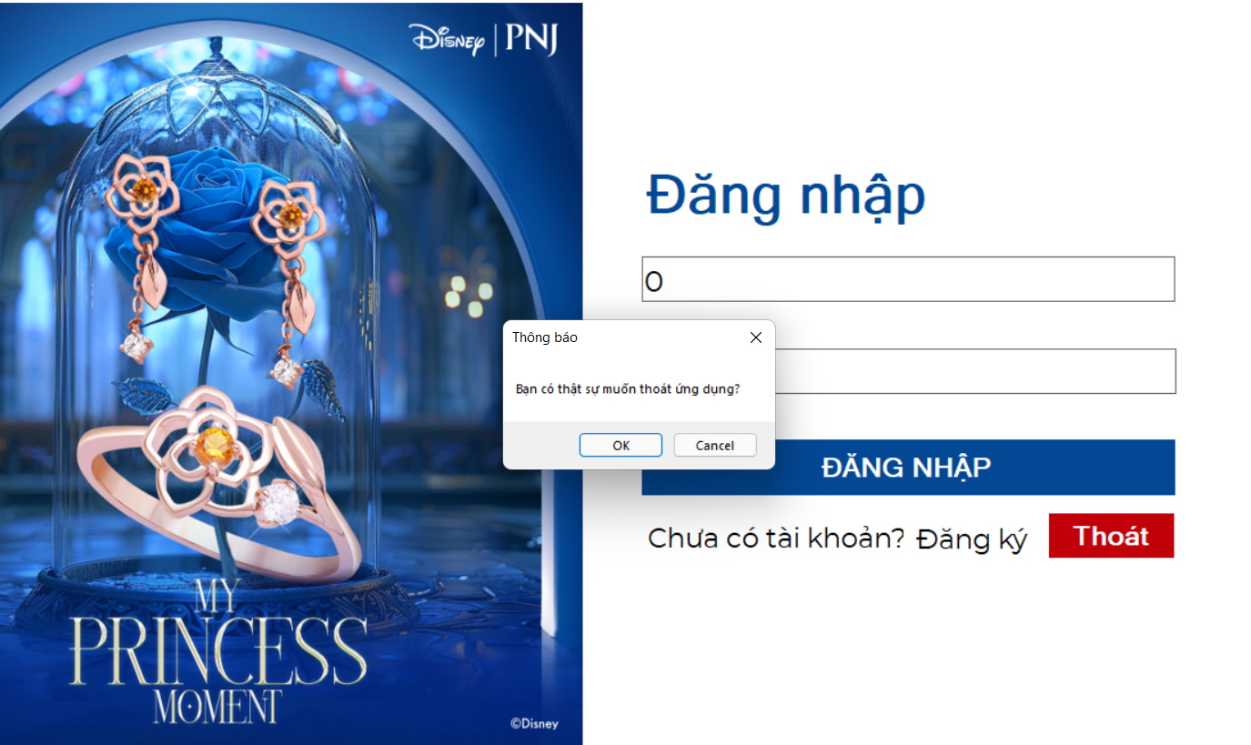

* Function Detail: when the user enters email and password in the input fields, the system will check to see if the account exists on the system. If not, a message will be displayed saying the account does not exist. If you enter an incorrect email, the system will display a message stating that the account name or password is incorrect. If you enter the correct email and password, the system will display the management page.

### Sign Up:

#### <<Sign Up>>

*[A function can be a screen or a non-screen function (listed in the part 3.1.5 above). In this part, you need to provide the details on the related function, focus on mentioning below information*

* *Function trigger: how this function is triggered (navigation path, a timing frequency, etc.*
* *Function description: actors/roles, purpose, interface, data processing, etc.*
* *Screen layout: mock-up prototype of the screen, sample below is for Manage Products screen*

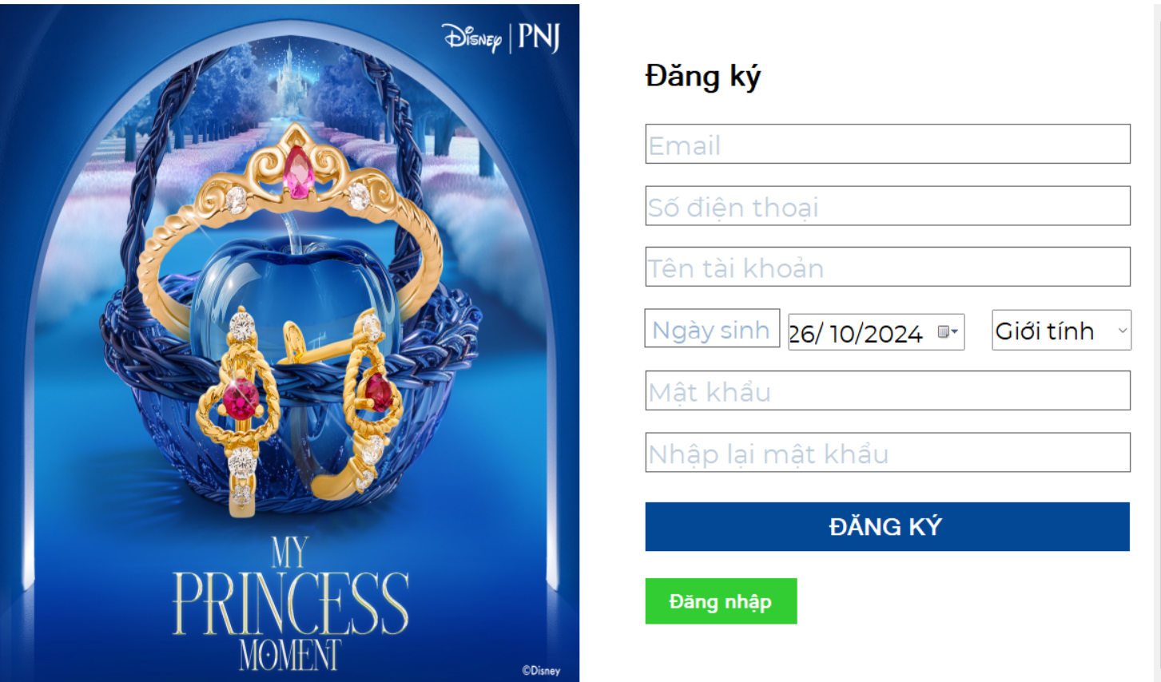

* *Function Details: provide explanation for the data, validation, business rules, functionalities (for both normal cases and abnormal cases), etc. of the function so that the reader can image how it works.*

In this screen, there is a sign-up function.

* Function Trigger: This function is activated after clicking the registration button on the Log In page, display time is 1.5 seconds
* Function Description: actor is admin, the purpose is to register an account to log in to use the application, after the user enters the required information, the data will be saved in the database, the user can later Use the newly entered data to log into the system
* Screnn Layout:
* Sign Up

**

* Log In



* Function Detail: the screen includes the login title, input fields email name, phone number, account name, date of birth, gender, password and re-enter the password. If the user does not enter all the information, the system will notify you, please enter all the information. If the user fails to enter the password, the system will display an incorrect password. If the information is filled in completely, the system will display If the password is entered again and matches the password, the system will display the account registered successfully.

### Product Management

#### Product Management:

This screen will be the product information management function

* Function trigger: This screen will be displayed first after the user successfully logs in on the Log In page, display time is 1.5 seconds.

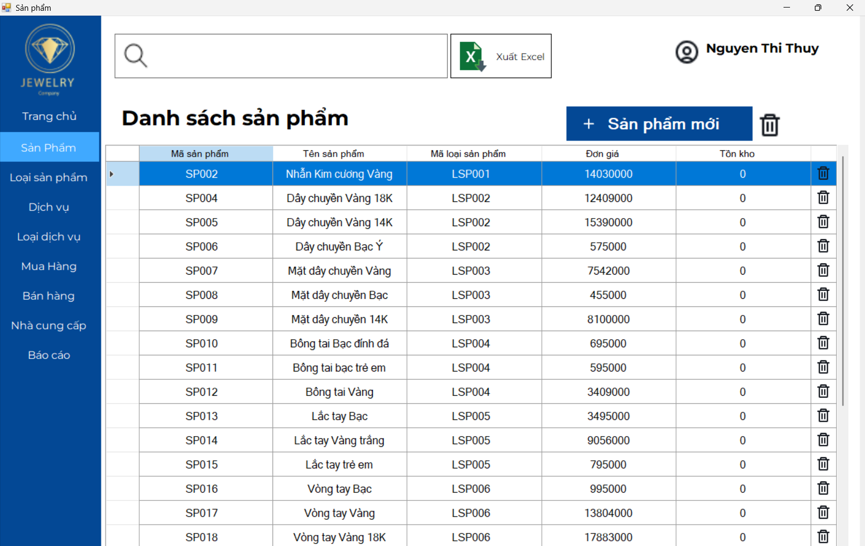

* Function Description: actor is the admin, this page is used to manage product information, including product code, product name, product type code, unit price and inventory.
* Screen layout:
* Product Management, Header, Sidebar, Action

Header

Product Management

Action



Sidebar

* Function Detail: The screen will pull information about all the products the store manages in the database, including product code, product name, product type code, unit price and inventory. Furthermore, users can also look up product information by entering the product code they want to look up. If you want to exit the search, just click the exit search button.

#### Add new product:

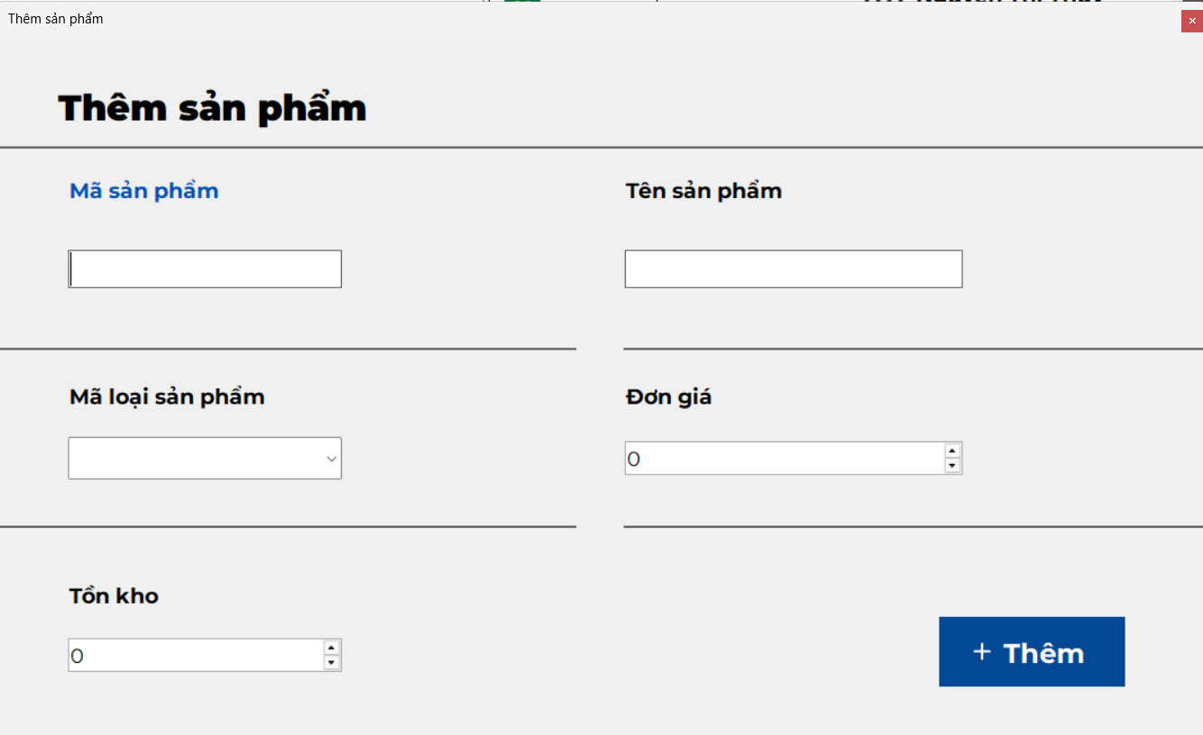

In this screen, the product will be added to the list of products.

* Function Trigger: This screen will be displayed after clicking the add product button on the product management page, display time is 1.5 seconds.
* Function Description: actor is admin, the purpose is to add products to the list of products in the system, the interface includes product code, product name, product type, unit price and inventory, after entering the information. information will be saved in the system database and displayed on the product management screen.
* Screen Layout:
* Title, Input Fields, Button



Button

Input Fields

Title

* Function Detail: If the user does not enter complete information, the system will display a message that please enter complete and correct information. After the user has entered complete information, the system will display a message that the product has been successfully added. click and return to the product management home page.

#### Delete product:

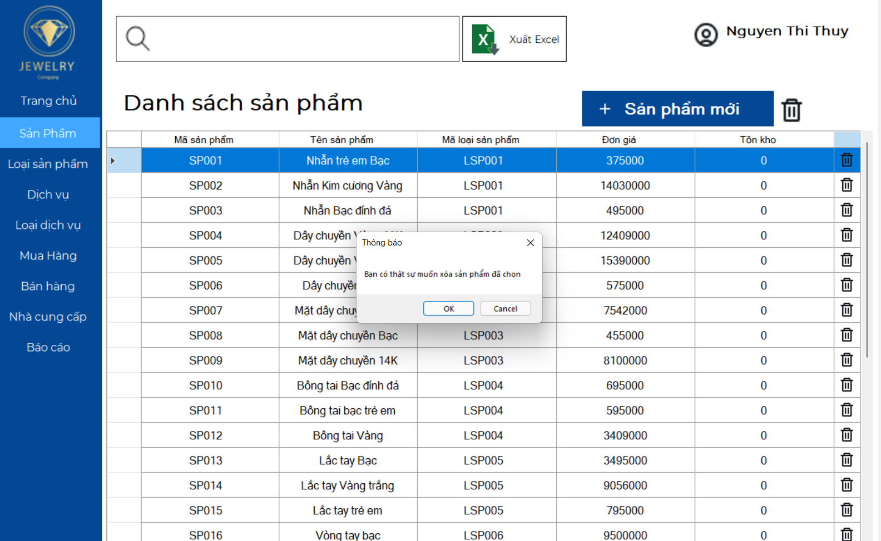

This function will perform the product deletion function.

* Function trigger: This function will be performed after the user presses the trash can icon at the top or the trash can icon in the same product row, display time is 1.5 seconds.
* Function Description: actor is admin, the purpose is to delete products, the interface includes a message that wants to delete the product and 2 options ok or cancel, and after confirmation, the product information will be deleted from the database, if If you cancel, return to the page and the product remains the same.
* Screen Layout:
* Notification.

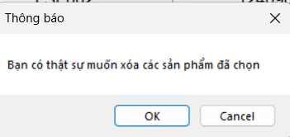

* Function Detail: When the user clicks on the trash icon, the user must first select the product they want to delete, otherwise the system will display a message to select the product to delete. After selecting the product to delete, if they press the delete button, Product information including product code, product name, product type, unit price, inventory will be deleted from the database, users can no longer sell and buy that product.

#### Excel export:

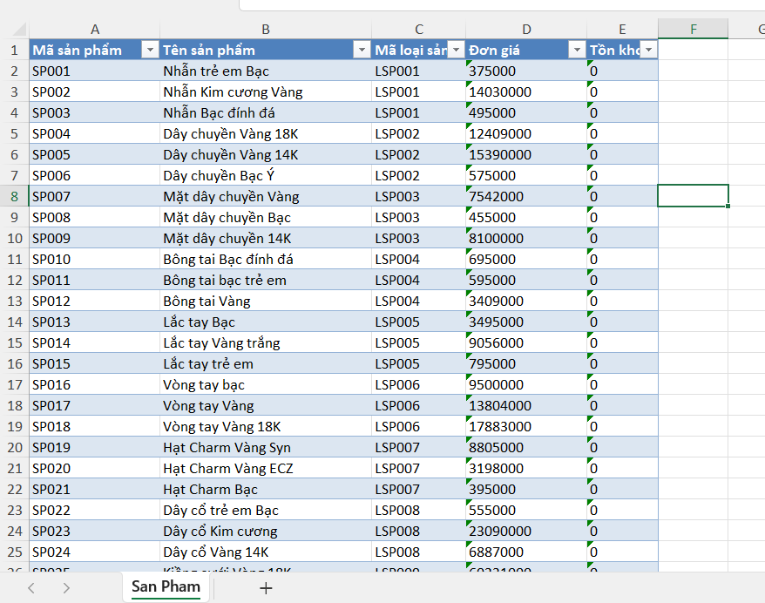

This page is used to export product information to Excel.

* Function trigger: This function is performed after clicking on the excel export button located on the product management page, display time is 1.5 seconds.
* Function Description: The actor is the admin, used to export information about the remaining products, the interface is an Excel file.
* Screen Layout: Excel file.



* Function Detail: Display information about all products on an excel sheet, including product code, product name, unit price, inventory, product type.

### Product Type Management:

#### Product Type Management:

This screen will be the product information management function

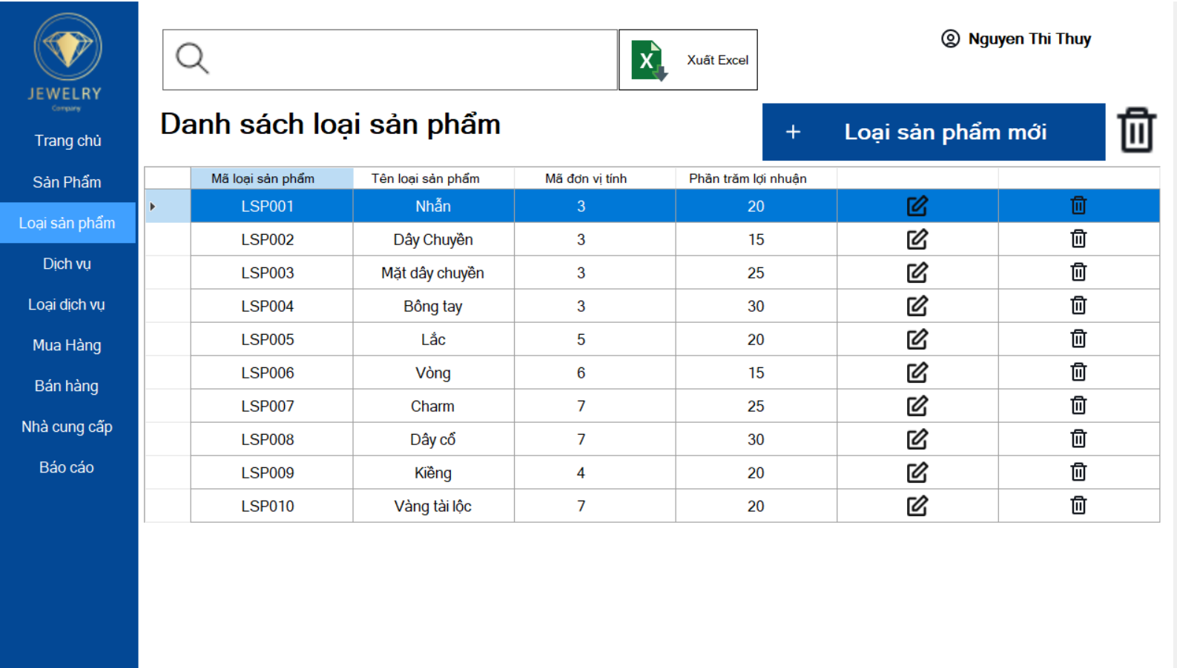

* Function trigger: This function will be displayed after the user clicks on the product name subitem in the left sidebar, display time is 1.5 seconds.
* Function Description: The actor is the admin, the function is to manage product types, the interface includes product code, product name, unit code, profit percentage, and a product search bar.
* Screen Layout:
* Product Type Management, Header, Sidebar, Action

Product Type Management

Action

Header



Sidebar

* Function Detail: The screen will retrieve information about all store-managed products in the database including product code, product name, unit of calculation, profit percentage. Furthermore, users can also look up product type information by entering the product type code they want to look up. If you want to exit the search, just click the exit search button.

#### Add new product type management:

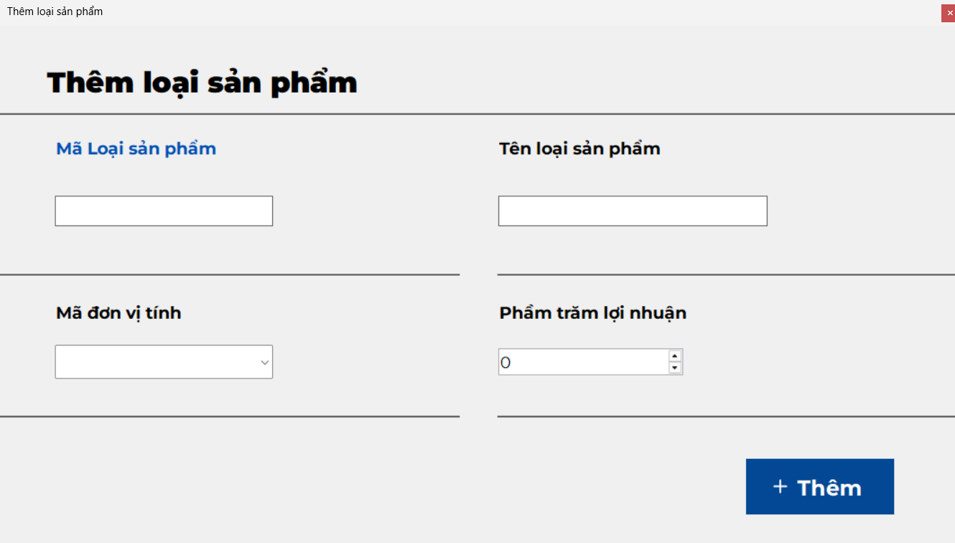

This function is used to add product types.

* Function trigger: This function is performed after clicking the add product type button on the product type management screen, the display time is 1.5 seconds.
* Function Description: actor is admin, the purpose is to add product types, the interface includes the title add product type, input fields include product type code, product type name, unit code, profit percentage and add button, after filling in all the information, the information about the product type will be saved in the database.
* Screen Layout:



Button

Input Fileds

Header

* Function Detail: When the user does not enter enough information, the system will display a message, please enter complete and correct information. If the user enters all information, the system will notify that the product type has been successfully added.

#### Update product type:

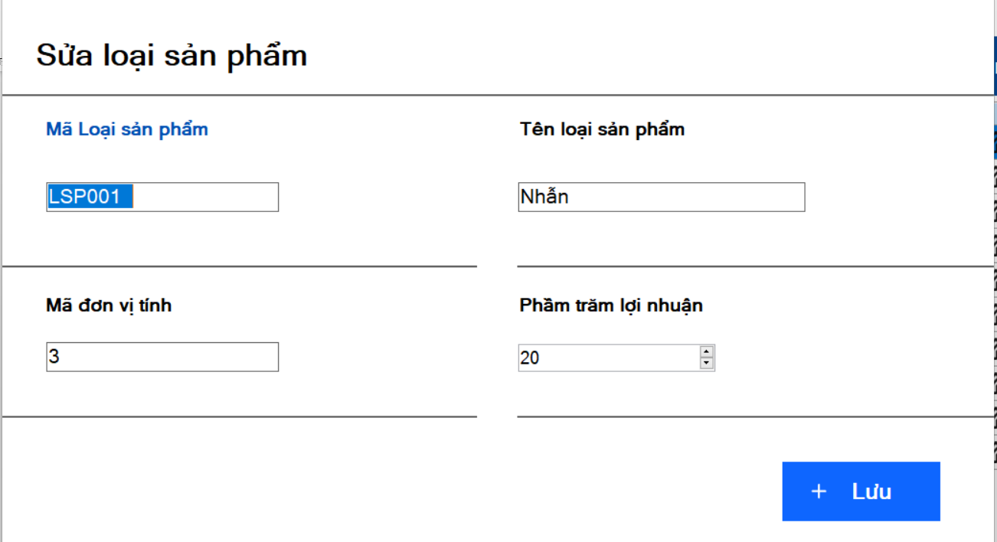

This function is used to update product information.

* Function trigger: This function is performed after the user clicks on the update icon next to the product name on the product type management screen.
* Function Description: actor is admin, used to update product type information, including title to edit product type, input fields that display previous product information and save button
* Screen Layout:

Input Fields



Button

Header

Header

* Function Detail: When on this page, the user will see the input fields displaying the previous product information, but the user can only edit the product name, unit code and profit percentage. Get the product type code, after editing and pressing the save button, the user will be notified that the product has been updated successfully.

#### Delete product type:

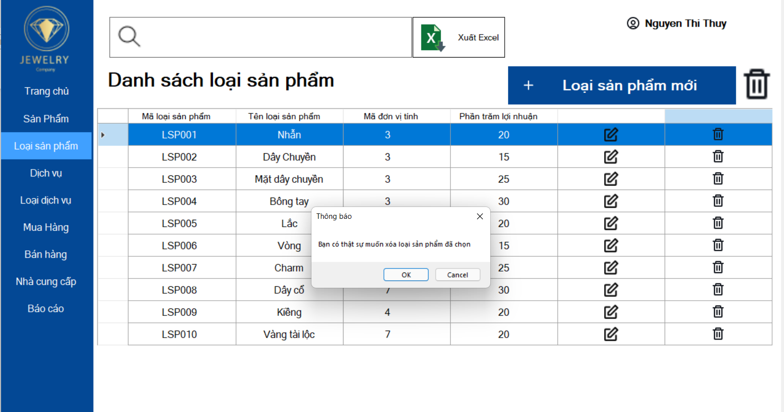

This screen is used to delete product types.

* Function trigger: This screen is activated when the user clicks on the trash icon on the product type management screen, the screen displays after 1.5 seconds.
* Function Description: actor is admin, used to delete product types, the interface includes a message saying whether you want to delete the product type, if the user chooses yes, the information about the product type will be deleted from the database, if the user If you choose no, the data type information will be preserved and returned to the product type management screen.
* Screen Layout: Notification

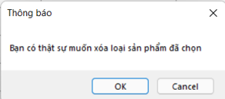

* Function Detail: When the user clicks on the trash icon, the user must first select the product type they want to delete, otherwise the system will display a message to select the product type to delete. After selecting the product type to delete, if they press the delete button, Product type information including product type code, product type name, unit code, profit percentage will be deleted from the database, users can no longer use that product type.

#### Excel export:

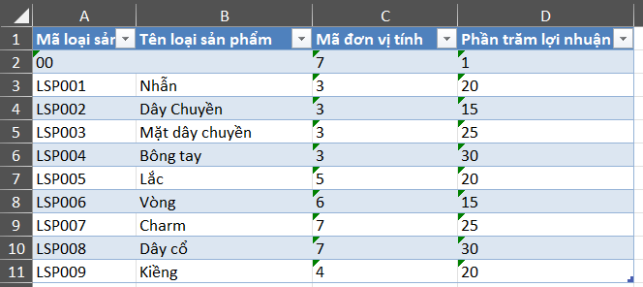

This page is used to export product type information to Excel.

* Function Trigger: This function is performed after clicking on the excel export button located on the product type management page, display time is 1.5 seconds.
* Function Description: The actor is the admin, used to export information about the remaining product types, the interface is an Excel file.
* Screen Layout: Excel file



* Function Detail: Display information about all products on an excel sheet, including product type code, product type name, unit code, profit percentage.

### Provider Management:

#### Provider Management:

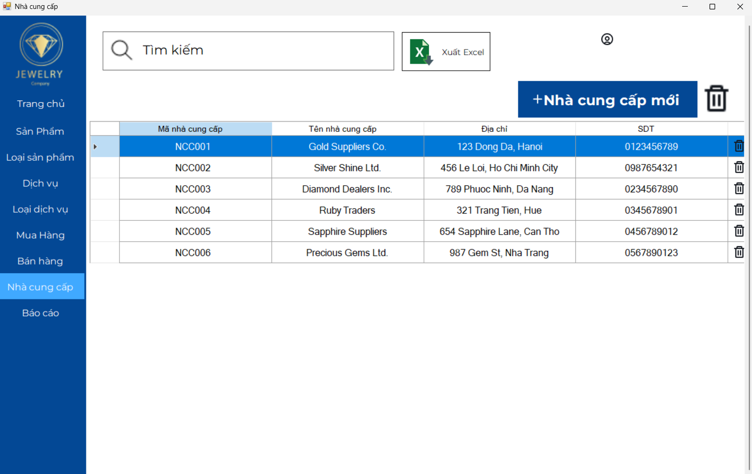

This screen is used to manage providers.

* Function trigger: This screen is displayed after the user selects the subitem named Provider located in the sidebar on the left, the screen displays after 1.5 seconds.
* Function Description: The actor is the admin, the function is to manage providers, the interface includes provider code, provider name, address, phone number, and a provider search bar.
* Screen Layout: Heading, Sidebar, Action, Management.



Action

Header

Provider Management

Sidebar

* Function Detail: The screen will retrieve information about all provider managed by the store in the database including provider code, provider name, address, phone number. Furthermore, users can also look up provider information by entering the provider code they want to look up. If you want to exit the search, just click the exit search button.

#### Add new provider:

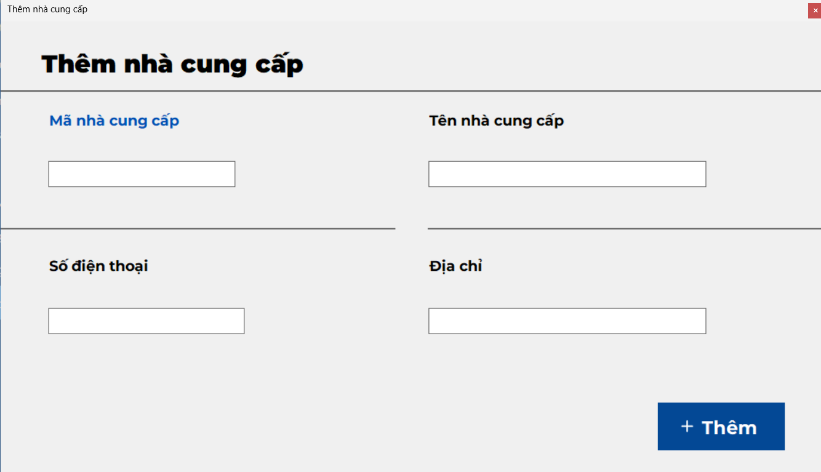

This screen is used to add providers.

* Function trigger: This function is performed after clicking the add provider button on the provider management screen, the display time is 1.5 seconds.
* Function Description: actor is admin, the purpose is to add new providers, the interface includes the title add provider, input fields include provider code, provider name, address, phone number and add button, after filling in all the information, the information about the provider will be saved in the database.
* Screen Layout: Header, Input Fields, Button



Input Fields

Header

Button

* Function Detail: When the user does not enter enough information, the system will display a message, please enter complete and correct information. If the user enters all information, the system will notify that the provider has been successfully added.

#### Delete provider:

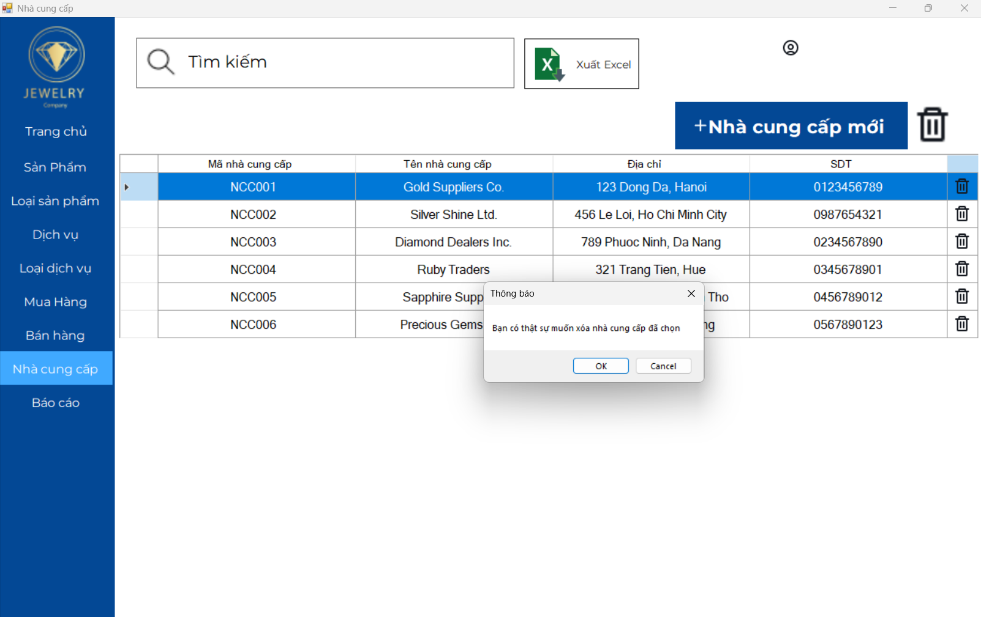

This screen is used to delete providers.

* Function trigger: This screen is activated when the user clicks on the trash icon on the provider management screen, the screen displays after 1.5 seconds.
* Function Description: actor is admin, used to delete provider, the interface includes a message saying whether you want to delete the provider, if the user chooses yes, the information about the provider will be deleted from the database, if the user If you choose no, the data type information will be preserved and returned to the provider management screen.
* Screen Layout: Notification

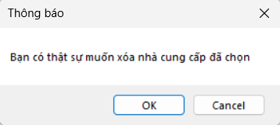

* Function Detail: When the user clicks on the trash icon, the user must first select the provider want to delete, otherwise the system will display a message to select the provider to delete. After selecting the provider to delete, if they press the delete button, provider information including provider code, provider name, address, phone number will be deleted from the database, users can no longer cooperate with that provider.

#### Excel export:

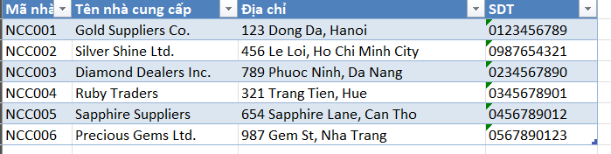

This page is used to export provider information to Excel.

* Function trigger: This function is performed after clicking on the excel export button located on the provider management page, display time is 1.5 seconds.
* Function Description: The actor is the admin, used to export information about the remaining providers, the interface is an Excel file.
* Screen Layout: Excel file.



* Function Detail: Display information about all providers on an excel sheet, including provider code, provider name, address, phone number.

### Purchase Order Management:

#### Purchase Order Management:

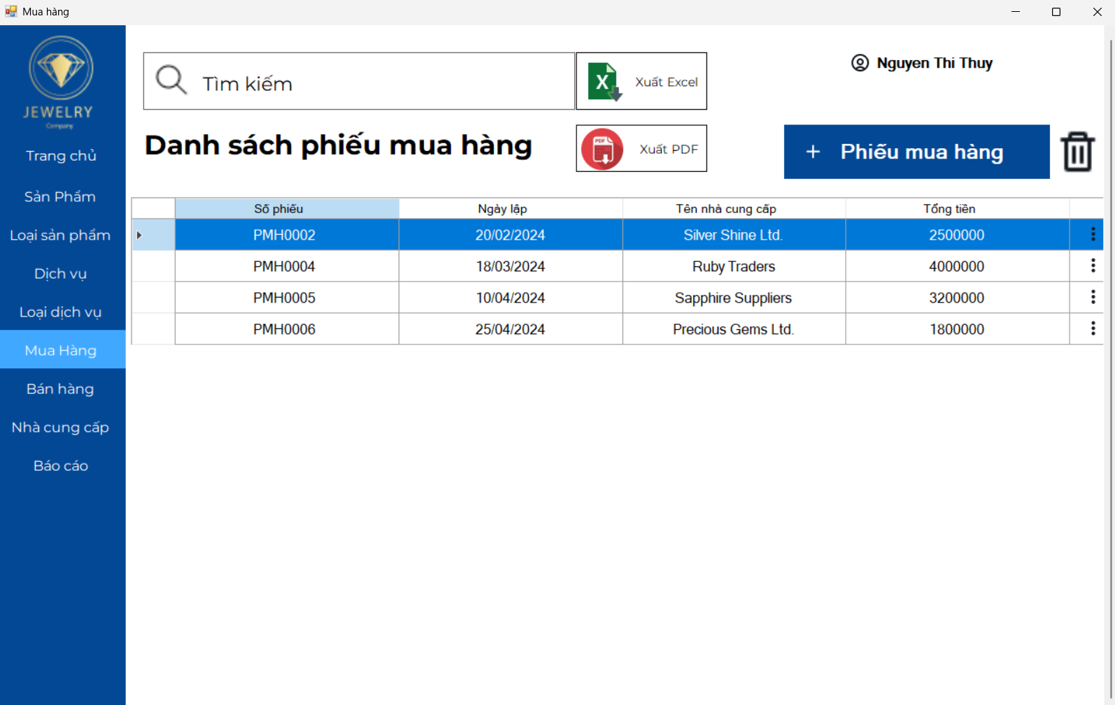

This screen is used to manage purchase orders.

* Function trigger: This screen is displayed after the user selects the subitem named Purchase order located in the sidebar on the left, the screen displays after 1.5 seconds.
* Function Description: The actor is the admin, the function is to manage purchase orders, the interface includes purchase orders code, creation date, provider’s name, total amount, and a purchase order search bar.
* Screen Layout: Header, Sidebar, Action, Management.



Action

Purchase Order Management

Header

Sidebar

* Function Detail: The screen will retrieve information about all store-managed purchase orders in the database including purchase order code, creation date, provider’s name, total amount. Furthermore, users can also look up purchase order information by entering the purchase order code they want to look up. If you want to exit the search, just click the exit search button.

#### Add new Purchase Order:

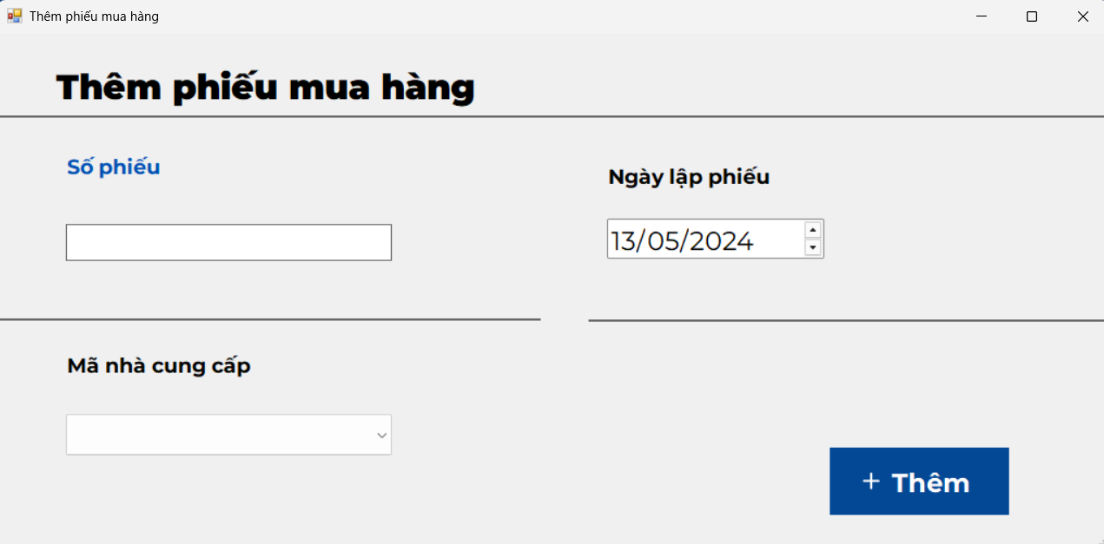

This screen is used to add purchase order.

* Function trigger: This function is performed after clicking the add purchase order button on the purchase order management screen, the display time is 1.5 seconds.
* Function Description: actor is admin, the purpose is to add new purchase order, the interface includes the title add purchase order, input fields include purchase order code, creation date, provider’s code and add button, after filling in all the information, the information about the purchase order will be saved in the database.
* Screen Layout: Header, Input Fields, Button

Input Fileds



Button

Header

* Function Detail: When the user does not enter enough information, the system will display a message, please enter complete and correct information. If the user enters all information, the system will notify that the purchase order has been successfully added.

#### Delete Purchase Order:

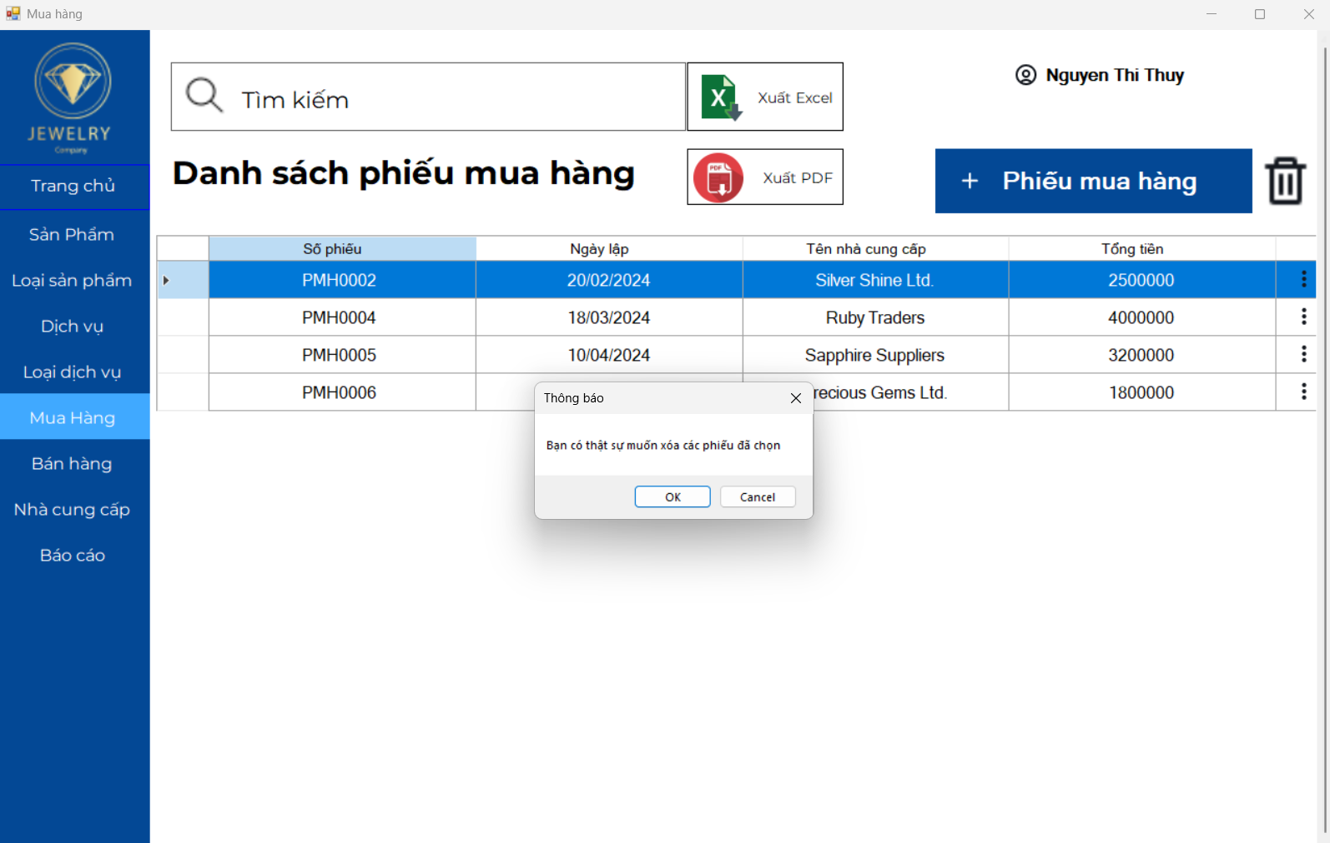

This screen is used to delete purchase order.

* Function trigger: This screen is activated when the user clicks on the trash icon on the purchase order management screen, the screen displays after 1.5 seconds.
* Function Description: actor is admin, used to delete purchase order, the interface includes a message saying whether you want to delete the purchase order, if the user chooses yes, the information about the purchase order will be deleted from the database, if the user If you choose no, the data type information will be preserved and returned to the purchase order management screen.
* Screen Layout: Notification

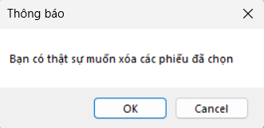

* Function Detail: When the user clicks on the trash icon, the user must first select the purchase order want to delete, otherwise the system will display a message to select the purchase order to delete. After selecting the purchase order to delete, if they press the delete button, purchase order information including purchase order code, creation date, provider’s name will be deleted from the database, users can no longer save that purchase order.

#### Excel export:

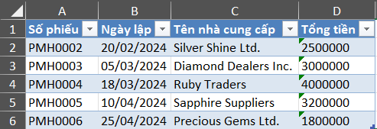

This page is used to export purchase order information to Excel.

* Function trigger: This function is performed after clicking on the excel export button located on the purchase order management page, display time is 1.5 seconds.
* Function Description: The actor is the admin, used to export information about the remaining purchase orders, the interface is an Excel file.
* Screen Layout: Excel file.



* Function Detail: Display information about all purchase orders on an excel sheet, including purchase order code, creation date, provider’s name, total amount.

#### PDF export:

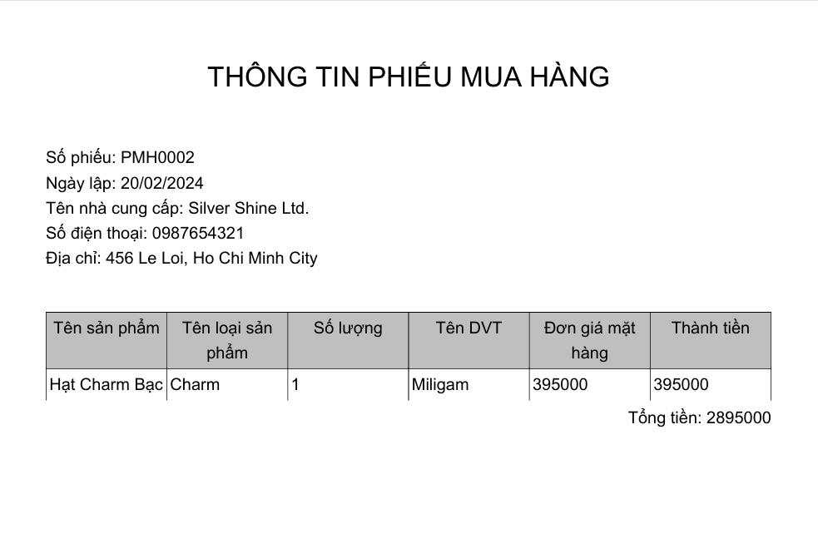

This page is used to export one purchase order information to PDF file.

* Function trigger: This function is performed after selecting one purchase order and clicking on the excel export button located on the purchase order management page, display time is 1.5 seconds.
* Function Description: The actor is the admin, used to export information about selected purchase order, the interface is an PDF file.
* Screen Layout: PDF file.



* Function Detail: After selecting a purchase order, the system will notify that 1 order has been selected, then the system will choose a location to write the file. After selecting, the system will display information about selected purchase order on a PDF file, including purchase order code, creation date, provider’s name, provider’s phone number, provider’s address, products information (product’s name, product type, quantity, unit name, item unit price, total money) contained in purchase order and total amount.

#### Add products in one Purchase order:

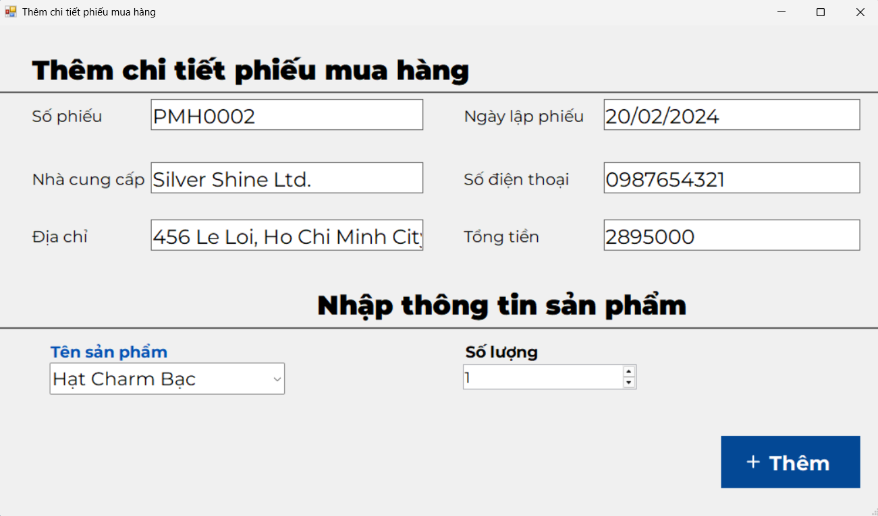

This screen is used to add products to purchase order.

* Function Trigger: This screen is displayed after pressing the three-dot button on a purchase order, then 3 options will appear and select the Add option, the display time is 1.5 seconds.
* Function Description: The actor is the admin; the purpose is to add products to the purchase order to buy from the provider. When the screen is displayed, the previous information will be displayed: purchase order code, creation date, provider's name, phone number, address, total amount, and below that there will be 2 boxes to fill in, 1 is the product selection stored in the database and 2 is the number of products purchased from the provider. Once fully entered, it will be added to the purchase voucher.
* Screen Layout: Title, Information, Dropdown menu, Button.

Dropdown menu

Button

Information

Title



* Function Detail: If the user enters missing information, the system will display a message asking to enter complete information. After entering complete information and pressing the Add button, the system will save the newly entered information into the database. The notification shows that the product has been added successfully and returns to the purchase order management page.

### Sell Order Management:

#### Sell Order Management:

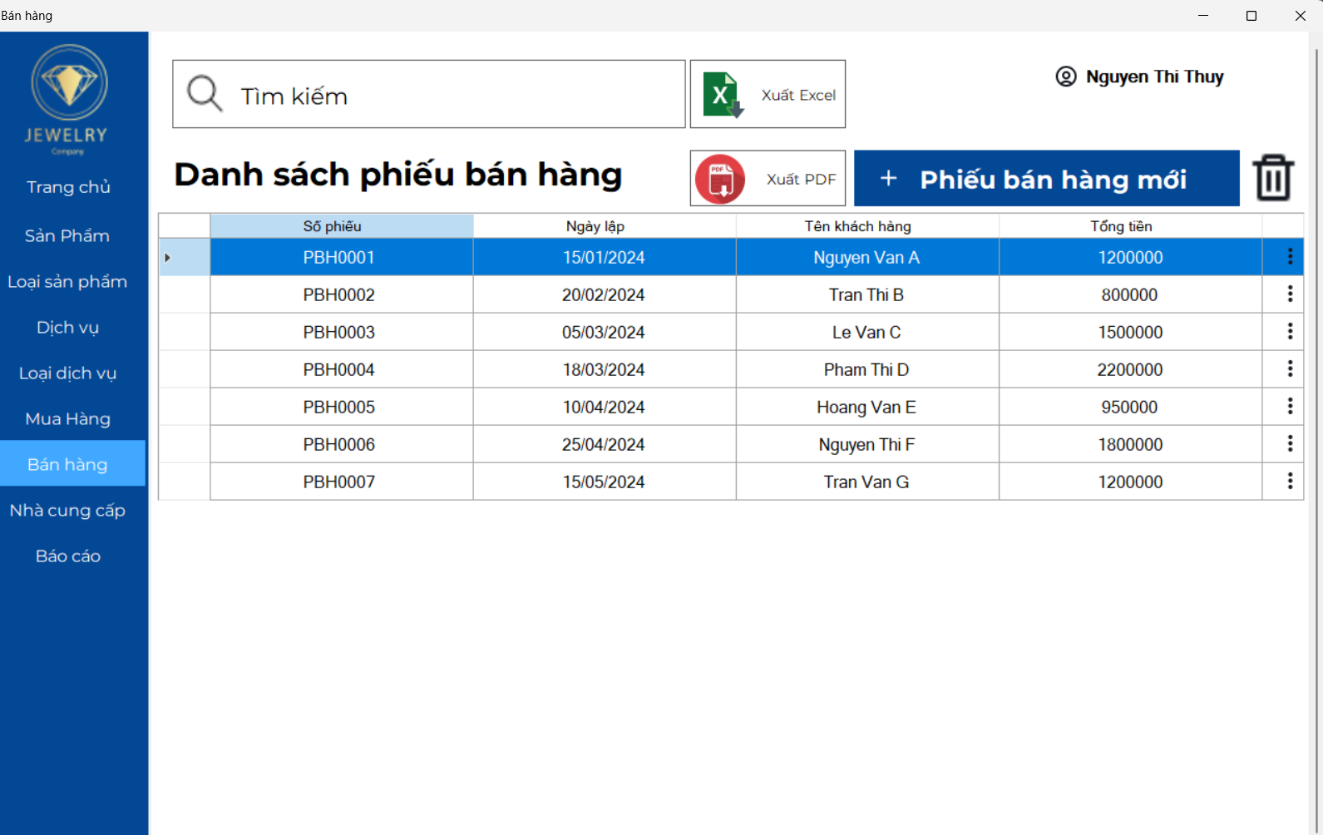

This screen is used to manage sell orders.

* Function trigger: This screen is displayed after the user selects the subitem named Sell order located in the sidebar on the left, the screen displays after 1.5 seconds.
* Function Description: The actor is the admin, the function is to manage sell orders, the interface includes sell orders code, creation date, customer’s name, total amount, and a purchase order search bar.
* Screen Layout: Header, Sidebar, Action, Management.



Action

Sell Order Management

Header

Sidebar

* Function Detail: The screen will retrieve information about all store-managed sell orders in the database including sell order code, creation date, customer’s name, total amount. Furthermore, users can also look up sell order information by entering the sell order code they want to look up. If you want to exit the search, just click the exit search button.

#### Add new Sell Order:

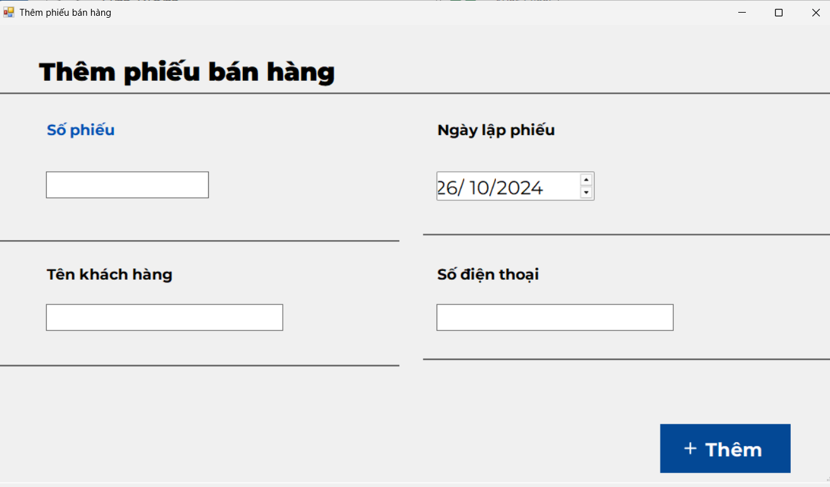

This screen is used to add sell order.

* Function trigger: This function is performed after clicking the add sell order button on the sell order management screen, the display time is 1.5 seconds.
* Function Description: actor is admin, the purpose is to add new sell order, the interface includes the title add sell order, input fields include sell order code, creation date, customer’s code and add button, after filling in all the information, the information about the sell order will be saved in the database.
* Screen Layout: Header, Input Fields, Button

Input Fields



Button

Header

* Function Detail: When the user does not enter enough information, the system will display a message, please enter complete and correct information. If the user enters all information, the system will notify that the sell order has been successfully added.

#### Delete Sell Order:

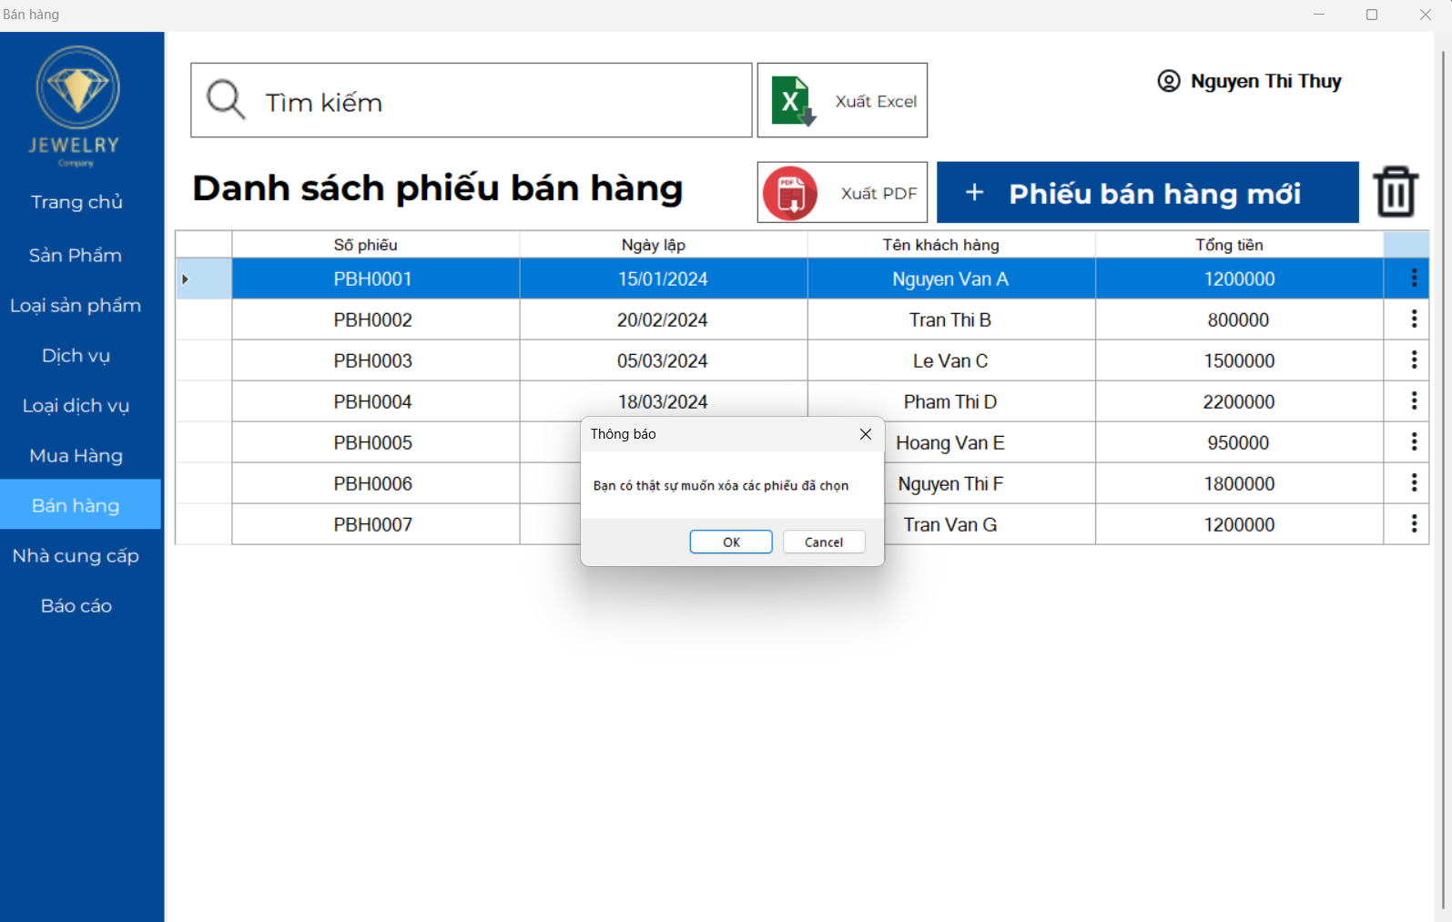

This screen is used to delete sell order.

* Function trigger: This screen is activated when the user clicks on the trash icon on the sell order management screen, the screen displays after 1.5 seconds.
* Function Description: actor is admin, used to delete sell order, the interface includes a message saying whether you want to delete the sell order, if the user chooses yes, the information about the sell order will be deleted from the database, if the user If you choose no, the data type information will be preserved and returned to the sell order management screen.
* Screen Layout: Notification

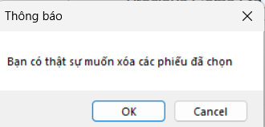

* Function Detail: When the user clicks on the trash icon, the user must first select the sell order want to delete, otherwise the system will display a message to select the sell order to delete. After selecting the sell order to delete, if they press the delete button, sell order information including sell order code, creation date, customer’s name will be deleted from the database, users can no longer save that sell order.

#### Excel export:

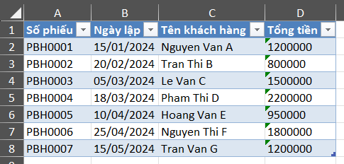

This page is used to export sell order information to Excel.

* Function trigger: This function is performed after clicking on the excel export button located on the sell order management page, display time is 1.5 seconds.
* Function Description: The actor is the admin, used to export information about the remaining sell orders, the interface is an Excel file.
* Screen Layout: Excel file.



* Function Detail: Display information about all sell orders on an excel sheet, including sell order code, creation date, customer’s name, total amount.

#### Add products in one Sell order:

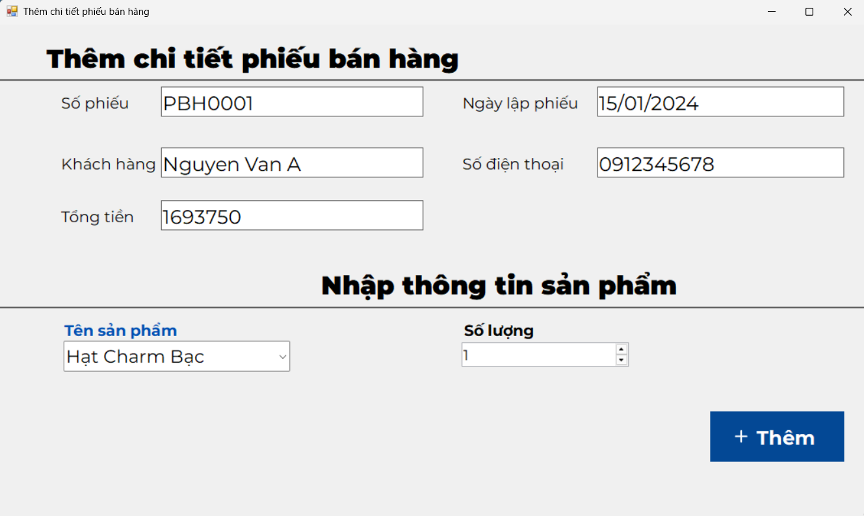

This screen is used to add products to sell order.

* Function Trigger: This screen is displayed after pressing the three-dot button on a sell order, then 3 options will appear and select the Add option, the display time is 1.5 seconds.
* Function Description: The actor is the admin; the purpose is to add products to the sell order to sell to the customer. When the screen is displayed, the previous information will be displayed: sell order code, creation date, customer's name, phone number, total amount, and below that there will be 2 boxes to fill in, 1 is the product selection stored in the database and 2 is the number of products purchased from the provider. Once fully entered, it will be added to the purchase voucher.
* Screen Layout: Title, Information, Dropdown menu, Button.

Information

Dropdown Menu

Button

Title

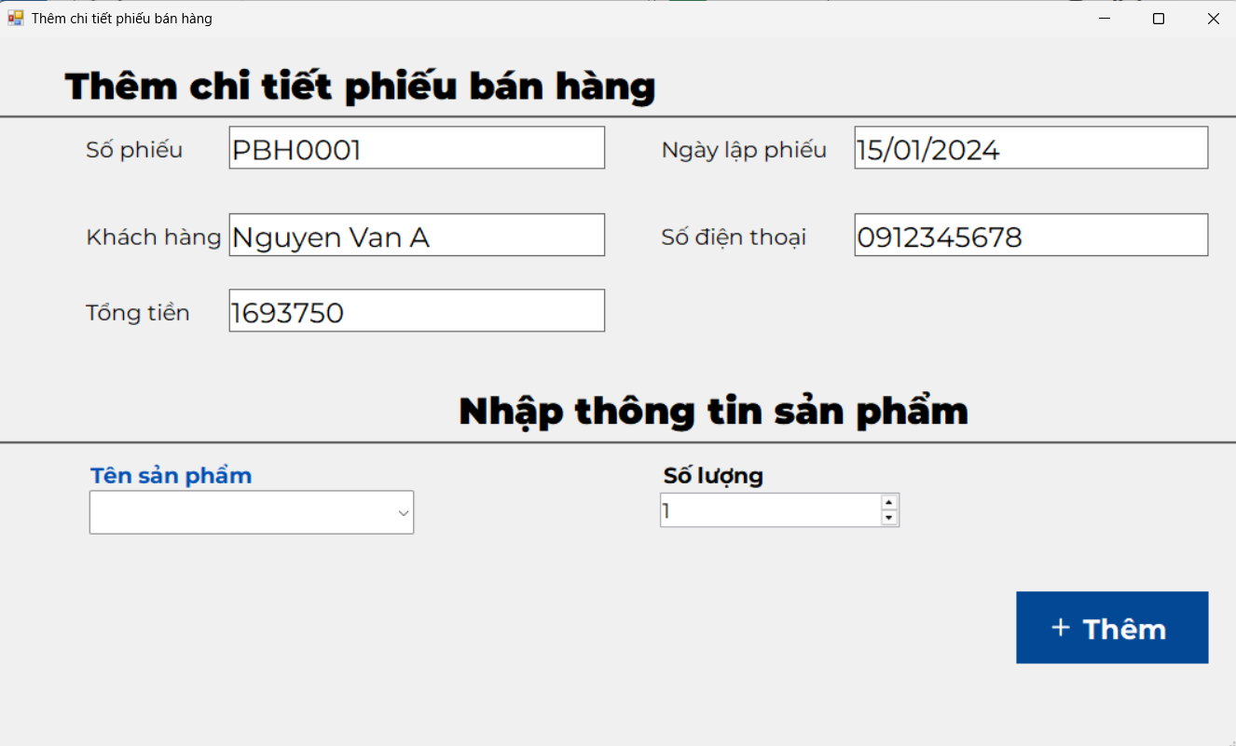

* Function Detail: If the user enters missing information, the system will display a message asking to enter complete information. If the user enters a quantity that exceeds the quantity currently in stock, the system will display a notification that the number of products exceeds the quantity in stock. After entering complete information and pressing the Add button, the system will save the newly entered information into the database. The notification shows that the product has been added successfully and returns to the sell order management page.

#### PDF export:

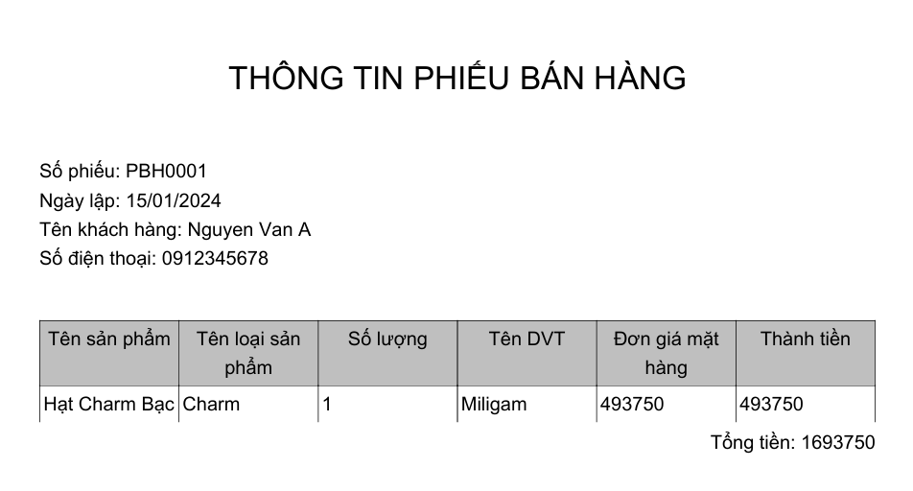

This page is used to export one sell order information to PDF file.

* Function trigger: This function is performed after selecting one sell order and clicking on the excel export button located on the sell order management page, display time is 1.5 seconds.
* Function Description: The actor is the admin, used to export information about selected sell order, the interface is an PDF file.
* Screen Layout: PDF file.



* Function Detail: After selecting a sell order, the system will notify that 1 order has been selected, then the system will choose a location to write the file. After selecting, the system will display information about selected sell order on a PDF file, including sell order code, creation date, customer’s name, customer’s phone number, products information (product’s name, product type, quantity, unit name, item unit price, total money) contained in sell order and total amount.

## Non-Functional Requirements

### External Interfaces

This section outlines the necessary communication mechanisms between the Jewelry Management System and its users, as well as any external hardware or software components. The system will support standard protocols for payment processing and inventory management, ensuring seamless integration with third-party services.

### Quality Attributes

#### Usability

|  |  |
| --- | --- |
| US-1: | A stack-navigation menu to help users move freely between sections. |
| US-2: | All of the buttons are labeled with the main functionality on them and color to help users not being confused about their functions. |
| US-3: | In the process of input data, if users violate the input regulation, the program will pop up to warn the users after they click on the “Confirm” button. (They cannot continue the process if the error is not solved) |
| US-4: | The system will provide tooltips for all major functions, offering brief descriptions to aid user understanding |
| US-5: | A dashboard overview will be available upon login, displaying key metrics and quick links to frequently used features. |

#### Reliability

|  |  |
| --- | --- |
| RE-1: | The system shall maintain an availability of 99.9%, ensuring it is operational and accessible 24/7, with scheduled maintenance communicated to users in advance. |
| RE-2: | The Mean Time Between Failures (MTBF) should be at least 1,200 hours, indicating a robust system that minimizes downtime. |
| RE-3: | In the event of a failure, the Mean Time To Repair (MTTR) must not exceed 1 hour, ensuring rapid recovery and minimal disruption to operations. |
| RE-4: | The system will achieve a minimum of 99% accuracy in transaction processing and inventory tracking, ensuring reliable outputs for business operations. |
| RE-5: | The system must not exceed 3 bugs per thousand lines of code (bugs/KLOC), maintaining high code quality and performance. |
| RE-6: | Bugs will be categorized as follows:   * Critical Bugs: Resulting in complete data loss or an inability to use essential functions. * Significant Bugs: Affecting major functionality but not resulting in complete outages. * Minor Bugs: Causing minor inconveniences that do not significantly affect user experience. |
| RE-7: | The system shall implement automated monitoring to detect and report failures or performance issues in real time, allowing for proactive maintenance and quick response to incidents. |

#### Performance

|  |  |
| --- | --- |
| PR-1 | All the screens (included input and output screens) must be set to ready for users within 3 seconds with the conditions:  - There is no error in terms of input regulation.  - Network latency is minimized and does not exceed 100 milliseconds. |
| PR-2 | The response time for any transaction (e.g., processing a sale, updating inventory) should not exceed 5 seconds, even during peak load. |
| PR-3 | Resource utilization (CPU, memory, and disk) should remain below 70% during peak operational hours to ensure optimal performance and responsiveness. |

#### Design Constraints

|  |  |
| --- | --- |
| DC-1 | All screen separate into three phase. After a phase has been finished, all function in previous phase can not be use. |
| DC-2 | Build tool is Neatbeans, use SQL Server as database |

#### On-line User Documentation and Help System Requirements

The system will include comprehensive online user documentation, featuring tutorials, FAQs, and a searchable help system to assist users in navigating the software and troubleshooting issues.

#### Interfaces

This section will detail the various interfaces of the system, including user interfaces for different roles (administrators, staff, customers), external system interfaces (payment processors, inventory systems), and API integrations for third-party services. Each interface will be designed to ensure ease of use and seamless interaction with other components.

## Data Requirements

### Logical Data Model

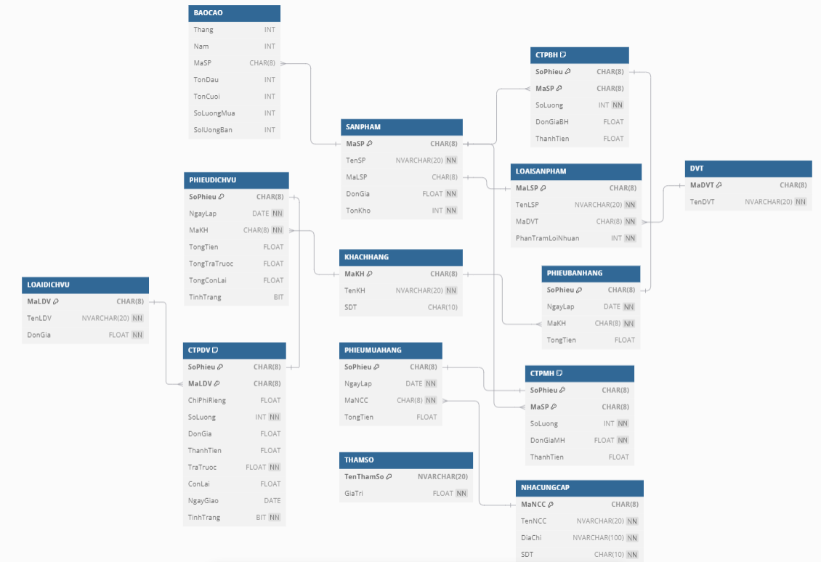

Figure 8.1‑1: 5.1 Logical Data Model

### Data Dictionary

|  |  |  |  |  |
| --- | --- | --- | --- | --- |
| **Data Element** | **Description** | **Composition or Data Type** | **Length** | **Values** |
| customer ID | ID number of customer | char | 8 |  |
| customer name | Name of customer | nvarchar | 20 |  |
| phone number | Phone number of customers | char | 10 |  |
| service bill ID | ID number of service bill | char | 8 |  |
| creation date | The date when service bill is created | date |  |  |
| total price | Total cost of a single unit of service item | float |  |  |
| total prepayment | Total amount paid by the customer for the service in advance | float |  |  |
| remaining total | The remaining amount needs to be paid for the service | float |  |  |
| statement | The statement of current service | bit |  | 1 or 0 |
| own cost | Separate costs for each case | float |  |  |
| quantity | Number of services used by customers | int |  |  |
| price | Unit price of each type of service | float |  |  |
| delivery date | The date when the product requiring service is completed and delivered to the customer | date |  |  |
| service type ID | ID number of service type | char | 8 |  |
| service type name | Name of service type | nvarchar | 20 |  |
| price | Price of service | float |  |  |
| calculation unit ID | ID number of calculation unit | char | 8 |  |
| calculation unit name | Name of calculation unit | nvarchar | 20 |  |
| product type ID | ID number of product type | char | 8 |  |
| product type name | Name of product type | nvarchar | 20 |  |
| profit percentage | Profit percentage for each product type | Int |  |  |
| product ID | ID number of product | char | 8 |  |
| product name | Name of product | nvarchar | 20 |  |
| price | Price of product | float |  |  |
| stock | Quantity in stock | int |  |  |
| provider ID | ID number of supplier | char | 8 |  |
| provider name | Name of supplier | nvarchar | 20 |  |
| address | Address of supplier | nvarchar | 20 |  |
| phone number | Phone number of suppliers | char | 10 |  |
| quantity | Number of products sold | int |  |  |
| selling price | Selling price of one product | float |  |  |
| quantity | Number of products bought | int |  |  |
| purchase price | Buying price of one product | float |  |  |
| sell order ID | ID number of sale bill | char | 8 |  |
| creation date | The date when sale bill is created | date |  |  |
| total price | Total price of sale bill | float |  |  |
| purchase order ID | ID number of purchase order | char | 8 |  |
| creation date | The date when buy bill is created | date |  |  |
| total price | Total price of buy bill | float |  |  |
| parameter name | Name of parameter | nvarchar | 20 |  |
| value | Value of parameter | float |  |  |
| month | The reporting month | Int |  |  |
| year | The reporting year | int |  |  |
| beginning inventory | Number of products not yet sold of last month | int |  |  |
| ending inventory | Number of products not yet sold in the end of this month | int |  |  |
| purchase quantity | The purchase quantity of product | int |  |  |
| sell quantiy | The sale quantity of product | int |  |  |

### Reports

|  |  |
| --- | --- |
| Report ID: | JMS-RPT-1 |
| Report Title: | Inventory Report |
| Report Purpose: | Admin wants to use inventory report to manage inventory, purchased products and sold products to manage the store's purchases and have a reasonable business plan |
| Priority: | Medium |
| Report Users: | Admin |
| Data Sources: | Database of product, purchase and sale order |
| Frequency and Disposition; | Report is generated on demand by an admin. Data in the report is static. Report is displayed on user's web browser screen on a computer. It can be printed if the display device permits printing. |
| Latency: | A complete report must be displayed to Admin within 1.5 seconds after it is requested. |
| Visual Layout: | Landscape mode |
| Header: | Report header shall contain the report title, and date range specified. |
| Report Body: | Fields shown and column headings:   * Product ID * Product Name * Beginning Inventory * Purchase Quantity * Sell Quantity * Ending Quantity * Calculation Unit |
| End-of-Report Indicator: | None |
| Interactivity: | None |
| Security Access Restrictions: | None |

## Requirement Appendix

### Business Rules

|  |  |
| --- | --- |
| ID | Rule Definition |
| BR-01 | Delivery time windows for jewellery orders are **3 days** |
| BR-02 | Deliveries must be completed between 10:00 A.M. and 2:00 P.M. local time, inclusive. |
| BR-03 | All items in a single order must be delivered to the same location. |
| BR-04 | All items in a single order must be paid for by using the same payment method. |
| BR-11 | If an order is to be delivered, the patron must pay by payroll deduction. |
| BR-12 | The order price is calculated as the sum of each jewellery item's price times the quantity ordered, plus applicable **sales tax**, plus a **delivery charge** if the delivery is outside the free delivery zone. |
| BR-24 | Only admin can create, modify, or delete jewellery listings in the system |

### Common Requirements

|  |  |
| --- | --- |
| ID | Rule Definition |
| CR-01 | The system must support multi-language options for international customers. |
| CR-02 | The system should provide mobile responsiveness for use on smartphones and tablets. |
| CR-03 | User data must be stored securely and comply with data protection regulations. |

### Application Messages List

|  |  |  |  |  |
| --- | --- | --- | --- | --- |
| **#** | **Message code** | **Message Type** | **Context** | **Content** |
| 1 | MSG01 | In line | There is not any search result | *No search results.* |
| 2 | MSG02 | In red, under the text box | Input-required fields are empty | *The * field is required.* |
| 3 | MSG03 | Toast message | Updating asset(s) information successfully | *Update asset(s) successfully.* |
| 4 | MSG04 | Toast message | Adding new asset successfully | *Add asset successfully.* |
| 5 | MSG05 | Toast message | Confirming email of asset hand-over is sent successfully | *A confirmation email has been sent to {email_address}.* |
| 6 | MSG06 | Toast message | Resetting asset information successfully | *Return asset(s) successfully.* |
| 7 | MSG07 | Toast message | Deleting asset information successfully | *Delete asset(s) successfully.* |
| 8 | MSG08 | In red, under the text box | Input value length > max length | *Exceed max length of {max_length}.* |
| 9 | MSG09 | In line | Username or password is not correct when clicking sign-in | *Incorrect user name or password. Please check again.* |